**ORGANIC ANALYSIS**

Experiment No.13

**Aim**: Identify the functional group present in the given organic compound.

|  |  |  |
| --- | --- | --- |
| **Experiment** | **Observations** | **Inference** |
| **1.Test for unsaturation**  Dissolve 0.2 ml of organic compound in 2 ml CCl4.Then added bromine water dropwise  **2.Test for carboxylic group**  **a) Sodium bicarbonate test**  Added a pinch of NaHCO3 to 0.2 ml of organic compound in a test tube.  **b) Ester test**  To 0.2 ml of organic compound added 4-5 drops of ethyl alcohol and 1-2 drops of Con.H2SO4 in a test tube and warm | Brown colour of bromine not discharged.  Brisk effervescence  Fruity smell | No unsaturation is present.  Carboxylic group is present.  Carboxylic group confirmed |

**Chemical equations:** (left hand side)

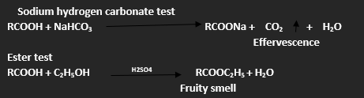

**RESULT**

**The given organic compound contains carboxylic acid (-COOH) functional group.**

**ORGANIC ANALYSIS**

Experiment No.14

**Aim**: Identify the functional group present in the given organic compound.

|  |  |  |
| --- | --- | --- |
| **Experiment** | **Observations** | **Inference** |
| **1.Test for unsaturation**  Dissolve 0.2 ml of organic compound in 2 ml CCl4.Then added bromine water dropwise  **2.Test for carboxylic group**  **Sodium bicarbonate test**  Added a pinch of NaHCO3 to 0.2 ml of organic compound in a test tube.  **3.Test for Phenolic group**  **a) Ferric chloride test**  Added 0.2 ml of organic compound to 2-3 ml neutral FeCl3 solution in a test tube.  **b) Liebermann’s Test**  To 2-3 crystals of sodium nitrite in a clean dry test tube added 1 ml of phenol. Heat gently and allow it to cool. Then added 1 ml of Con.H2SO4 and shook the content.  Added water.  Added excess of NaOH solution. | Brown colour of bromine not discharged.  No brisk effervescence  Violet colouration  Deep blue colour  Red colour  Blue colour | No unsaturation is present.  Carboxylic group is absent.  Phenolic group is present.  Phenolic group confirmed. |

**Chemical equations:** (left hand side)

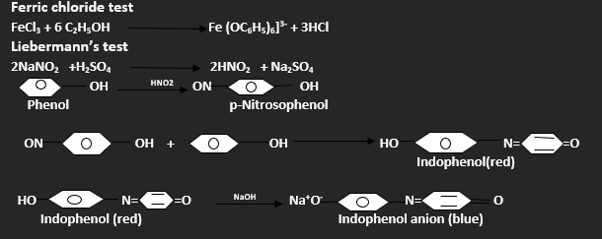

**RESULT**

**The given organic compound contains phenolic functional group.**

**ORGANIC ANALYSIS**

Experiment No.15

**Aim**: Identify the functional group present in the given organic compound.

|  |  |  |
| --- | --- | --- |
| **Experiment** | **Observations** | **Inference** |
| **1.Test for unsaturation**  Dissolve 0.2 ml of organic compound in 2 ml CCl4.Then added bromine water dropwise  **2.Test for carboxylic group**  **Sodium bicarbonate test**  Added a pinch of NaHCO3 to 0.2 ml of organic compound in a test tube.  **3.Test for Phenolic group**  **Ferric chloride test**  Added 0.2 ml of organic compound to 2-3 ml neutral FeCl3 solution in a test tube.  **4.Test for Alcoholic group**  **a) Ceric ammonium nitrate test**  Take about 1 ml of the given liquid in a clean dry test tube and add few drops of ceric ammonium nitrate reagent and shake it well.  **b)** **Ester Test**  Take about 1 ml of the give liquid in a clean dry test tube, add about 1 ml glacial acetic acid and 2-3 drops of conc. sulphuric acid. Warm the mixture on a water bath for about 10 minutes. Pour it into about 20 ml of cold water taken in a beaker and smell. | Brown colour of bromine not discharged.  No brisk effervescence  No Violet colouration  Red colour is developed.  A fruity smell is produced | No unsaturation is present.  Carboxylic group is absent.  Phenolic group is absent.  Presence of alcoholic group  Presence of alcoholic group  Confirmed. |

**Chemical equations:** (left hand side)

**Ceric ammonium nitrate test**

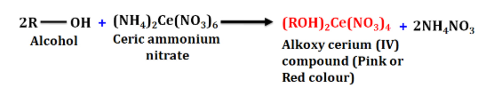

**ESTER TEST**

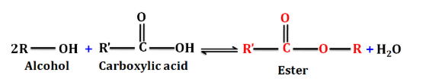

**RESULT**

**The given organic compound contains Alcoholic functional group.**

**ORGANIC ANALYSIS**

Experiment No.16

**Aim**: Identify the functional group present in the given organic compound.

|  |  |  |
| --- | --- | --- |
| **Experiment** | **Observations** | **Inference** |
| **1.Test for unsaturation**  Dissolve 0.2 ml of organic compound in 2 ml CCl4.Then added bromine water dropwise  **2.Test for carboxylic group**  **Sodium bicarbonate test**  Added a pinch of NaHCO3 to 0.2 ml of organic compound in a test tube.  **3.Test for Phenolic group**  **Ferric chloride test**  Added 0.2 ml of organic compound to 2-3 ml neutral FeCl3 solution in a test tube.  **4.Test for Alcoholic group**  **Ceric ammonium nitrate test**  Take about 1 ml of the given liquid in a clean dry test tube and add few drops of ceric ammonium nitrate reagent and shake it well.  **5.Test for carbonyl group**  **2,4-Dintrophenyl hydrazine Test**  Take a small quantity of the given compound in a clean dry test tube, add rectified spirit until the compound just dissolves. Now add few drops of 2, 4-dinitrophenyl hydrazine solution. Cork the test tube, shake the mixture and allow it to stand for 5 minutes.  **6. Test for Aldehydes**  **Tollen’s Test**  Take about 1 ml of organic compound in a clean test tube and add 2-3 ml of Tollen’s reagent. Warm the test tube on a water bath for about 5 minutes.  **7.** **Fehling’s Test**  Take 1 ml each of Fehling’s solution A and B in a test tube. Add 4-5 drops of the given organic liquid (or 0.2g if solid) and warm the test in a water bath for 4-5 minutes. | Brown colour of bromine not discharged.  No brisk effervescence  No Violet colouration  No red colour is developed.  Yellow or orange precipitate is formed.  Shining silver mirror is formed.  Red precipitate is formed. | No unsaturation is present.  Carboxylic group is absent.  Phenolic group is absent.  Absence of alcoholic group  Presence of carbonyl group.  Presence of aldehydic group is confirmed.  Presence of aldehydic group is confirmed. |

**Chemical equations:** (left hand side)

**2,4-dinitrophenyl hydrazine test (2,4-DNP test)**

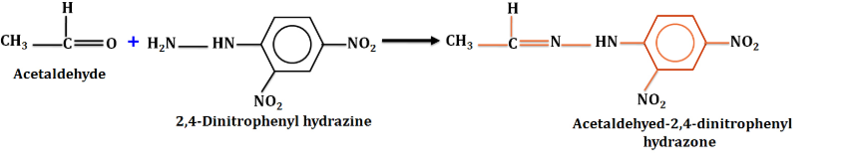

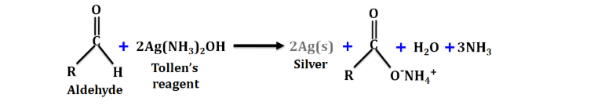

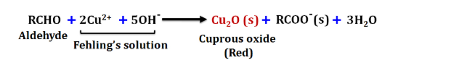

**RESULT**

**The given organic compound contains Aldehydic functional group.**

**ORGANIC ANALYSIS**

**Experiment No.17**

**Aim**: Identify the functional group present in the given organic compound.

|  |  |  |
| --- | --- | --- |
| **Experiment** | **Observations** | **Inference** |
| **1.Test for unsaturation**  Dissolve 0.2 ml of organic compound in 2 ml CCl4.Then added bromine water dropwise  **2.Test for carboxylic group**  **Sodium bicarbonate test**  Added a pinch of NaHCO3 to 0.2 ml of organic compound in a test tube.  **3.Test for Phenolic group**  **Ferric chloride test**  Added 0.2 ml of organic compound to 2-3 ml neutral FeCl3 solution in a test tube.  **4.Test for Alcoholic group**  **Ceric ammonium nitrate test**  Take about 1 ml of the given liquid in a clean dry test tube and add few drops of ceric ammonium nitrate reagent and shake it well.  **5.Test for carbonyl group**  **2,4-Dintrophenyl hydrazine Test**  Take a small quantity of the given compound in a clean dry test tube, add rectified spirit until the compound just dissolves. Now add few drops of 2, 4-dinitrophenyl hydrazine solution. Cork the test tube, shake the mixture and allow it to stand for 5 minutes.  **6. Test for Aldehydes**  **Tollen’s Test**  Take about 1 ml of organic compound in a clean test tube and add 2-3 ml of Tollen’s reagent. Warm the test tube on a water bath for about 5 minutes.  **7.** **Test for Ketones**  **m-Dinitrobenzene Test**  Take a small quantity of the given compound in a clean test tube and add about 0.1g of finely powdered m-dinitrobenzene. Now add about 1 ml of dilute sodium hydroxide solution and shake it well.  **Sodium nitroprusside Test**  Dissolve a small quantity of sodium nitroprusside in about 1 ml of distilled water in a clean test tube and then add a small quantity of the given compound. Shake the test tube well and add sodium hydroxide solution dropwise. | Brown colour of bromine not discharged.  No brisk effervescence  No Violet colouration  No red colour is developed.  Yellow or orange precipitate is formed.  No silver mirror is formed.  Violet colour is formed which slowly fades away.  Red colouration. | No unsaturation is present.  Carboxylic group is absent.  Phenolic group is absent.  Absence of alcoholic group  Presence of carbonyl group.  Absence of aldehydic group.  Presence of ketonic group.  Presence of ketonic group is confirmed. |

**Chemical equations:** (left hand side)

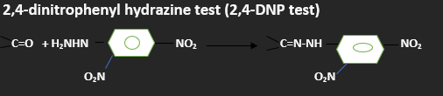

**Sodium nitroprusside Test**

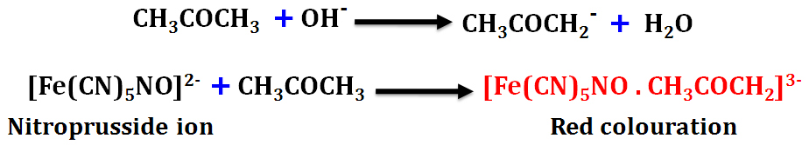

**RESULT**

**The given organic compound contains Ketonic functional group.**

**ORGANIC ANALYSIS**

**Experiment No.18**

**Aim**: Identify the functional group present in the given organic compound.

|  |  |  |
| --- | --- | --- |
| **Experiment** | **Observations** | **Inference** |
| **1.Test for unsaturation**  Dissolve 0.2 ml of organic compound in 2 ml CCl4.Then added bromine water dropwise  **2.Test for carboxylic group**  **Sodium bicarbonate test**  Added a pinch of NaHCO3 to 0.2 ml of organic compound in a test tube.  **3.Test for Phenolic group**  **Ferric chloride test**  Added 0.2 ml of organic compound to 2-3 ml neutral FeCl3 solution in a test tube.  **4.Test for Alcoholic group**  **Ceric ammonium nitrate test**  Take about 1 ml of the given liquid in a clean dry test tube and add few drops of ceric ammonium nitrate reagent and shake it well.  **5.Test for carbonyl group**  **2,4-Dintrophenyl hydrazine Test**  Take a small quantity of the given compound in a clean dry test tube, add rectified spirit until the compound just dissolves. Now add few drops of 2, 4-dinitrophenyl hydrazine solution. Cork the test tube, shake the mixture and allow it to stand for 5 minutes.  **6. Test for Amines**  **Carbylamines test**  Take a small quantity of solid KOH in a clean dry test tube and add about 2 ml of ethanol. Warm the test tube until the pellets dissolve. To this add a few drops of chloroform and small amount of the given compound and warm gently.  **Nitrous acid Test**  Make a solution of about 1 g of sodium nitrite in about 5 ml distilled water in a test tube and cool it in an ice bath. In a separate test tube, dissolve a small quantity of the given compound in about 1 ml of conc. sulphuric acid and cool this also in ice bath. Mix both the solutions. | Brown colour of bromine not discharged.  No brisk effervescence  No Violet colouration  No red colour is developed.  No Yellow or orange precipitate is formed.  An offensive smell is produced.  Bubbles of nitrogen gas. | No unsaturation is present.  Carboxylic group is absent.  Phenolic group is absent.  Absence of alcoholic group  Absence of carbonyl group.  Presence of primary amine.  Presence of primary aliphatic amine. |

**Chemical equations:** (left hand side)

**Carbylamines test**

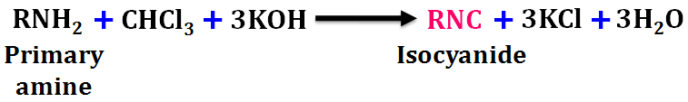

**Nitrous acid Test**

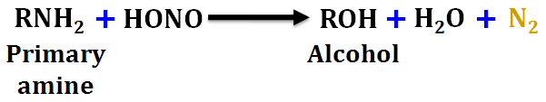

**RESULT**

**The given organic compound contains Amine functional group.**